**CIS 481 – Intro to Information Security**

**IN-CLASS EXERCISE # 1**

Names of team members: **Adrian Boone, Savanah Kennedy, Trisia Baltazar, Ryan Smith**

Logistics

A. Get into your regular team

B. Discuss and complete the assignment together. Don’t just assign different problems to each teammate! That defeats the purpose of team-based learning.

C. Choose a recorder to prepare the final copy to submit to instructor in Blackboard.

**Problem 1**

The CIA triad presents three essential characteristics of information that must be protected. However, most agree that these three characteristics are not the only ones that need to be protected. Other characteristics include authenticity, accuracy, possession, timeliness and utility. If you were tasked with creating an information security *rectangle*, instead presenting FOUR characteristics of information, which would you choose and why? (8 pts.)

**Utility. The security of information is not as important if the information isn’t useful. If the information you are trying to protect has no value then why is it being protected? Likewise, information with different amounts of utility will be treated differently; information that is of more critical importance is likely to have more robust security measures associated with it, whereas information that is less important may be treated with less rigor.**

**Problem 2**

In 1991, John McCumber proposed a model for Information Security that uses a 3-D cube, as below. Describe the three dimensions of the McCumber cube. (9 pts.)

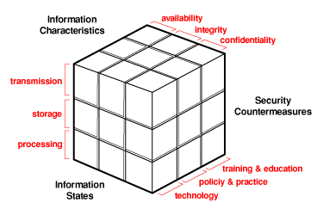

**Information states involve processing, storage and transmission. Processing means that there are certain operations happening to data and is in a state where it can be modified to achieve a certain result. Storage means that data is at rest and is stored in memory. Transmission means that data is transferring from one to location to another.**

**Security countermeasures are practices to help ensure information security. Technology can be having virus protection software or hardware with the purpose of enhancing security. Policy & practice refers to actions and rules that people abide by to ensure security. Not plugging in your own thumb drive on company computers may be a policy. Training & education refer to the training and potential courses people go through to learn more about security and what they can do to ensure their information is protected.**

**Information characteristics are simply the characteristics of the information. Availability is how easy information can be accessed without obstacles and if it is in the correct format. Integrity is if the information is whole and complete. Confidentiality is when information is protected from unauthorized users.**

**All of these dimensions together make the McCumber Cube which contains areas that must be acknowledged to ensure secure information systems.**

**Problem 3**

How can the practice of information security be described as both an art and a science? How does security as a social science influence its practice? (8 pts.)

**IS as an art: There is no right answer for information security. It’s an art in that you have to find the right set of security practices and procedures for your organization. There isn’t a uniform set that will work for every organization.**

**IS as a science: There are ways to objectively measure information security. There are best practices that guide its application.**

**IS as a social science: Individuals are some of the most important factors in information security, and some of the most prominent points of failure. Social science and implementation of policy can help reduce the attack surface that’s inherent to human beings.**